Clean Code Principles - Follow Code Style and Indentation
# Source: AI Source: Provided by: [Data Path: Persons Table -> ID Column: 1, Name_En Column: Motasem Essam] -> From: [Chatgpt (GPT‑5 Mini)] on [12/9/2025]
Following a consistent code style and proper indentation makes your code readable, clean, and professional.
👉 Good formatting is not optional—it’s part of writing clean code.

🔑 Why It Matters
# Source: AI Source: Provided by: [Data Path: Persons Table -> ID Column: 1, Name_En Column: Motasem Essam] -> From: [Chatgpt (GPT‑5 Mini)] on [12/9/2025]
- Improves readability
- Makes code easier to scan quickly
- Reduces errors and misunderstandings
- Helps teams collaborate effectively

❌ Bad Example (Poor Formatting)
# Source: AI Source: Provided by: [Data Path: Persons Table -> ID Column: 1, Name_En Column: Motasem Essam] -> From: [Chatgpt (GPT‑5 Mini)] on [12/9/2025]
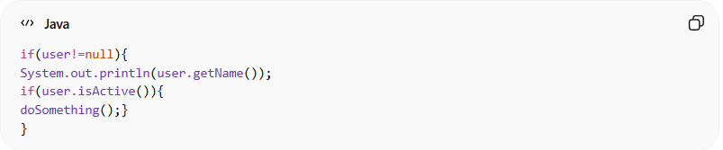
if(user!=null){
System.out.println(user.getName());
if(user.isActive()){
doSomething();}
}
👉 Problems:
- No spacing
- No indentation
- Hard to read and understand

✅ Good Example (Clean Formatting)
# Source: AI Source: Provided by: [Data Path: Persons Table -> ID Column: 1, Name_En Column: Motasem Essam] -> From: [Chatgpt (GPT‑5 Mini)] on [12/9/2025]
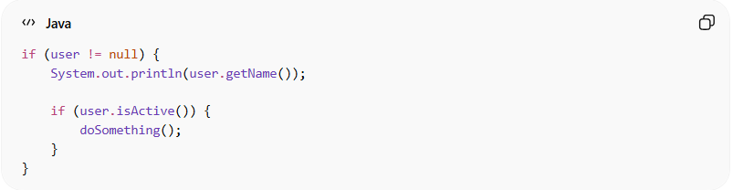
if (user != null) {
System.out.println(user.getName());

if (user.isActive()) {
doSomething();
}
}
👉 Benefits:
- Clear structure
- Easy to follow logic
- Professional appearance

🎯 Best Practices

1. Use Proper Indentation
# Source: AI Source: Provided by: [Data Path: Persons Table -> ID Column: 1, Name_En Column: Motasem Essam] -> From: [Chatgpt (GPT‑5 Mini)] on [12/9/2025]
❌ Bad:
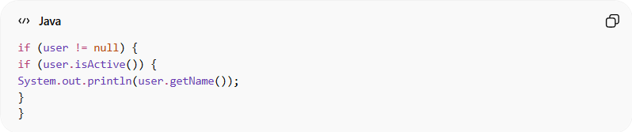
if (user != null) {
if (user.isActive()) {
System.out.println(user.getName());
}
}
✔️ Good:
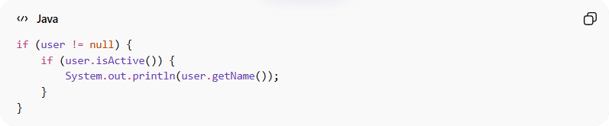
if (user != null) {
if (user.isActive()) {
System.out.println(user.getName());
}
}
- Indent code blocks consistently (usually 2 or 4 spaces)
- Each nested level should be clearly visible

2. Add Spaces for Readability
# Source: AI Source: Provided by: [Data Path: Persons Table -> ID Column: 1, Name_En Column: Motasem Essam] -> From: [Chatgpt (GPT‑5 Mini)] on [12/9/2025]
❌ Bad:
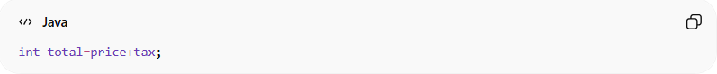
int total=price+tax;
✔️ Good:
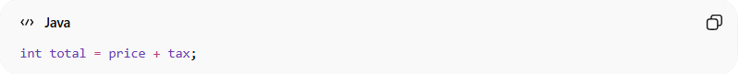
int total = price + tax;

3. Keep Line Length Reasonable
# Source: AI Source: Provided by: [Data Path: Persons Table -> ID Column: 1, Name_En Column: Motasem Essam] -> From: [Chatgpt (GPT‑5 Mini)] on [12/9/2025]
❌ Bad:
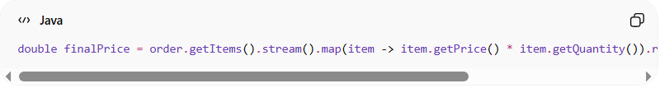
double finalPrice = order.getItems().stream().map(item -> item.getPrice() * item.getQuantity()).reduce(0.0, (a, b) -> a + b) * 1.15;
✔️ Good:
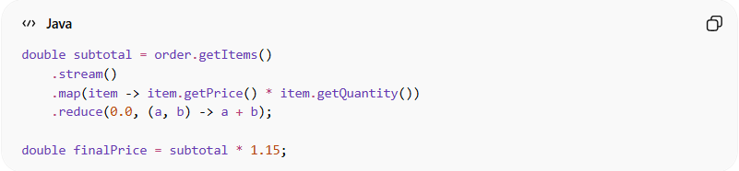
double subtotal = order.getItems()
.stream()
.map(item -> item.getPrice() * item.getQuantity())
.reduce(0.0, (a, b) -> a + b);

double finalPrice = subtotal * 1.15;
- Avoid very long lines
- Break lines when needed

4. Use Consistent Braces Style
# Source: AI Source: Provided by: [Data Path: Persons Table -> ID Column: 1, Name_En Column: Motasem Essam] -> From: [Chatgpt (GPT‑5 Mini)] on [12/9/2025]
❌ Bad:
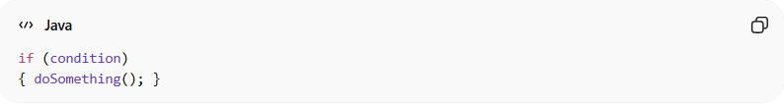
if (condition)
{ doSomething(); }
✔️ Good:
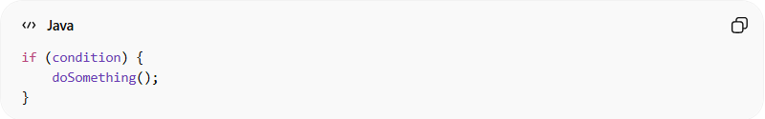
if (condition) {
doSomething();
}

5. Separate Code with Blank Lines
# Source: AI Source: Provided by: [Data Path: Persons Table -> ID Column: 1, Name_En Column: Motasem Essam] -> From: [Chatgpt (GPT‑5 Mini)] on [12/9/2025]
❌ Bad:
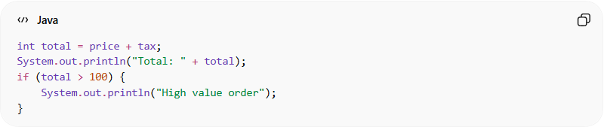
int total = price + tax;
System.out.println("Total: " + total);
if (total > 100) {
System.out.println("High value order");
}
✔️ Good:
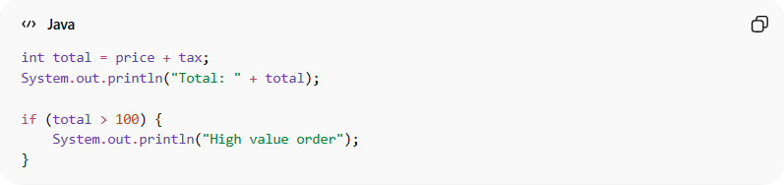
int total = price + tax;
System.out.println("Total: " + total);

if (total > 100) {
System.out.println("High value order");
}
- Use spacing to group related logic

⚙️ Pro Tip
# Source: AI Source: Provided by: [Data Path: Persons Table -> ID Column: 1, Name_En Column: Motasem Essam] -> From: [Chatgpt (GPT‑5 Mini)] on [12/9/2025]
Use tools to enforce style automatically:
- IDE formatters (IntelliJ, VS Code)
- Linters (Checkstyle, ESLint)

💡 Key Idea
# Source: AI Source: Provided by: [Data Path: Persons Table -> ID Column: 1, Name_En Column: Motasem Essam] -> From: [Chatgpt (GPT‑5 Mini)] on [12/9/2025]
Clean formatting makes your code readable without effort.

🚫 Common Mistakes
# Source: AI Source: Provided by: [Data Path: Persons Table -> ID Column: 1, Name_En Column: Motasem Essam] -> From: [Chatgpt (GPT‑5 Mini)] on [12/9/2025]
- Mixing tabs and spaces
- Inconsistent indentation
- Writing code in one line
- Ignoring formatting rules

🧾 Summary
# Source: AI Source: Provided by: [Data Path: Persons Table -> ID Column: 1, Name_En Column: Motasem Essam] -> From: [Chatgpt (GPT‑5 Mini)] on [12/9/2025]
Following code style and indentation helps you:
- Write clean and readable code
- Reduce confusion and mistakes
- Improve team collaboration
- Maintain a professional codebase

